

**Medication Practice Guide**  
**Easy Read**

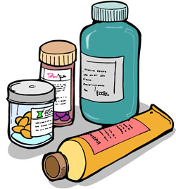

This practice guide goes with the Medication Policy.

It is for staff at AMPEY PTY LTD who assist clients with administering medication.

Many participants at AMPEY need to take medication. Some participants can do this independently, while others need assistance from their supporting staff.

AMPEY staff need to be trained to administer medication to participants.

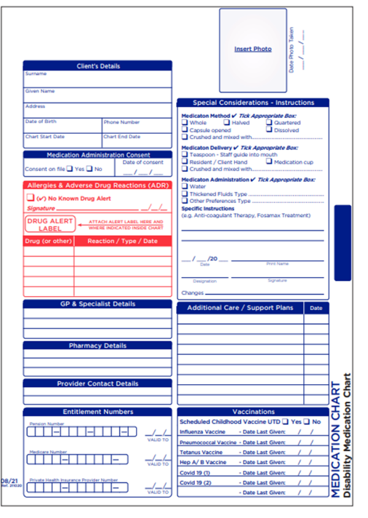

**What do staff need to know?**

AMPEY staff can only give medication when it is documented on the correct form.

This form is called a **Medication Authority Form.** It is also known as a **MAF.**

The form needs to say ALL the medication that a participant takes. It says how a participant must take their medication also.

Only these people can write on the MAF:

* A doctor
* A nurse practitioner
* A dentist

Participants may take medication in different ways. This can be: Oral, Topical, Inhalant, Peg, Subcutaneous.

Medication that needs to be taken at the same time each day. This is called **Regular Medication.**

Medication that is only taken when it is needed. This is called **PRN.**Medication that is taken for a short time. This is called **Short term.**

Each different type of medication has its own medication signing section. **Regular medication** is the Blue area. **PRN** is the Green area. **Short term** medication is the Red area.

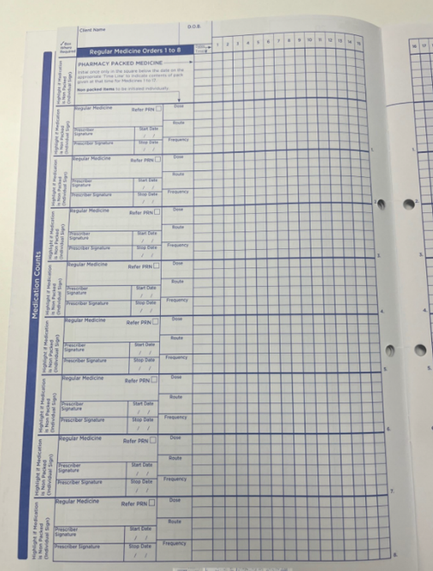Every time a participant takes medication it must be written down on the right chart.   
  
This chart is called a **Medication Authority Form (MAF).**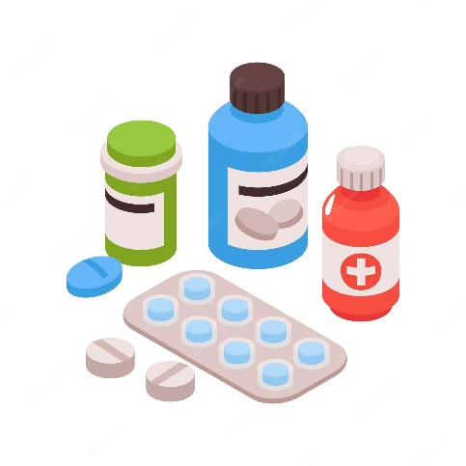

Each participant has their own chart.

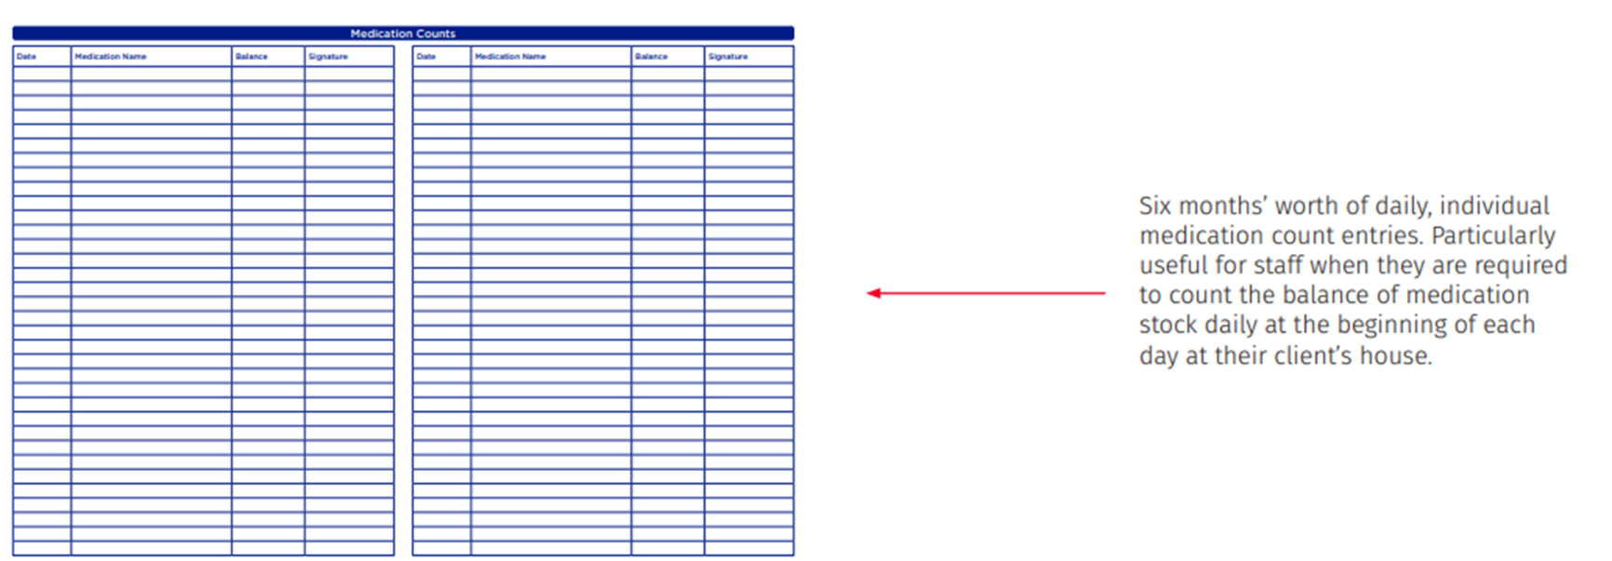A participant might have two charts one for the house and one for program. Check you sign the right chart.   
  
In a medication folder you will find: The MAF, The CMI (Consumer Medication Information), The webster pak and pill bob and the Patient Health Summary if available.

Medication counts are to be completed every shift to ensure all medication is accounted for.

**S8 and S4D medications** have special legal controls.

Every time a participant takes S8/S4D medication it must be written down on a S8/S4D Count Sheet as well as the MAF. The Count Sheet is kept with the S8/S4D medications.

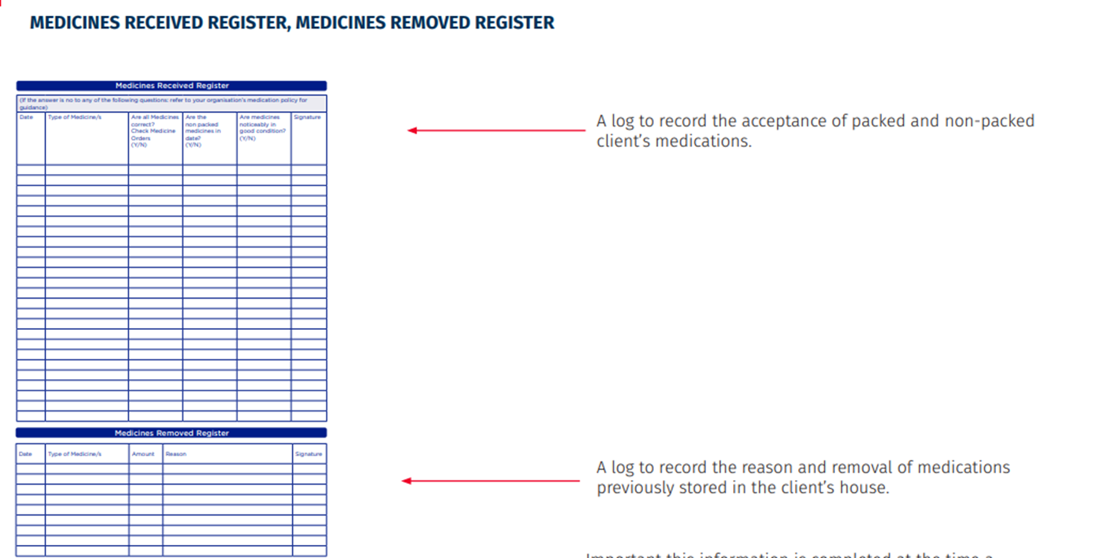

**When in Supported Independent Living (SIL)** two staff (when available) must check any new medication from the pharmacy or brought in by a participant.

These must be written down on a **Medication Check-In Form**.



Why must staff follow this guide?

Participants can get sick if they do not get the right medication.

Staff must follow the training and rules of AMPEY. They must always give medication in the right way to keep participants safe.

It is the right thing to do and also a legal requirement.

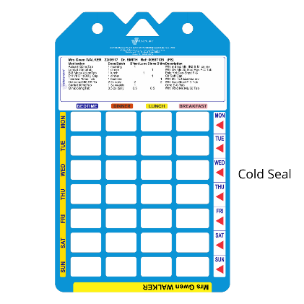Who must follow this guide?

**All** AMPEY staff who help participants to take medication must follow this guide.

Staff must be trained to give medication.

They must also have an assessment to say they are able to administer medication.

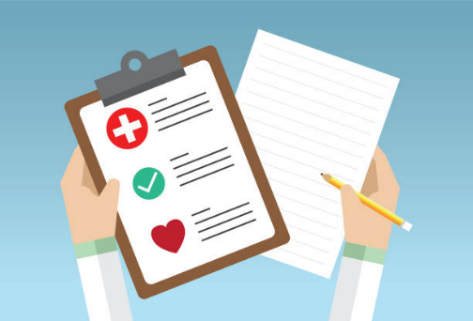

What staff MUST do

There are things all staff must do when they give medication.

Ask the participant for consent. The participant needs to agree you can give them medication.

If the participant can’t show you their consent, you must tell them you are going to give them their medication.

Take out the participants folder and medications, one at a time.

Check you know how to give the medication.

Look at the participant’s **Mealtime Management Plan and** **Medication Administration Summary.**

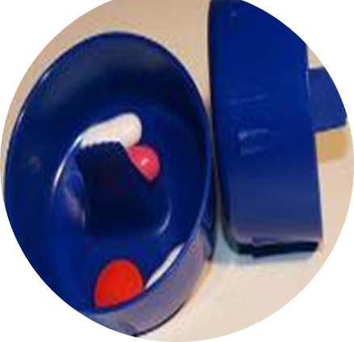Look at other plans the participant has, like **Complex Bowel Care Management Plan,** if extra medications are to be given.

Get what you need, and take to the participant. You will need:

* Medication Folder
* Medication Blister/Webster Pack.
* Any medication from the fridge.
* Any topical creams
* 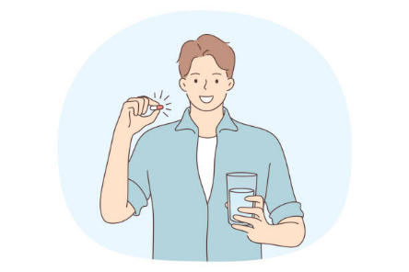Any equipment like gloves or Pil-Bob.
* Medicine cup or syringe (as stated on medication)
* Pill crusher (As stated on medication)



Check the medication you are giving with another staff member if available.

If you are the only staff member there, you need to check the medication twice for safety.

Follow safe hygiene when you give medication. This means:

* Wash your hands
* Wear gloves
* Use a Pil-Bob.

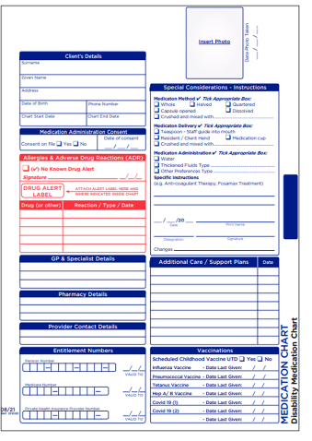Check the **MAF** with the other staff member, or double check the MAF twice if you are the only staff member there.

Check the details on the MAF:

* Medication Packs
* Patient Health Summary

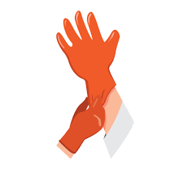

Check the medication details on the MAF:

* 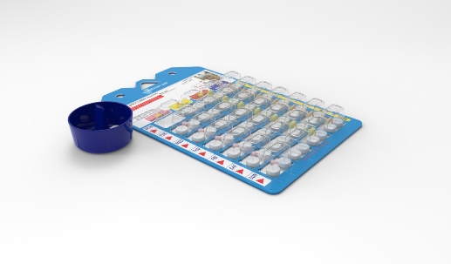Right person
* Right medication
* Right time
* Right dose
* Route
* Right Documentation
* Remember the customer has the Right to refuse

The MAF must have clear information that you can read and follow. If not, you must phone the participant's doctor.

Check the MAF and Webster Pak to make sure medication has not already been given.

Check the medication using the ”**7 Rights of Medication”.** This means:

1. 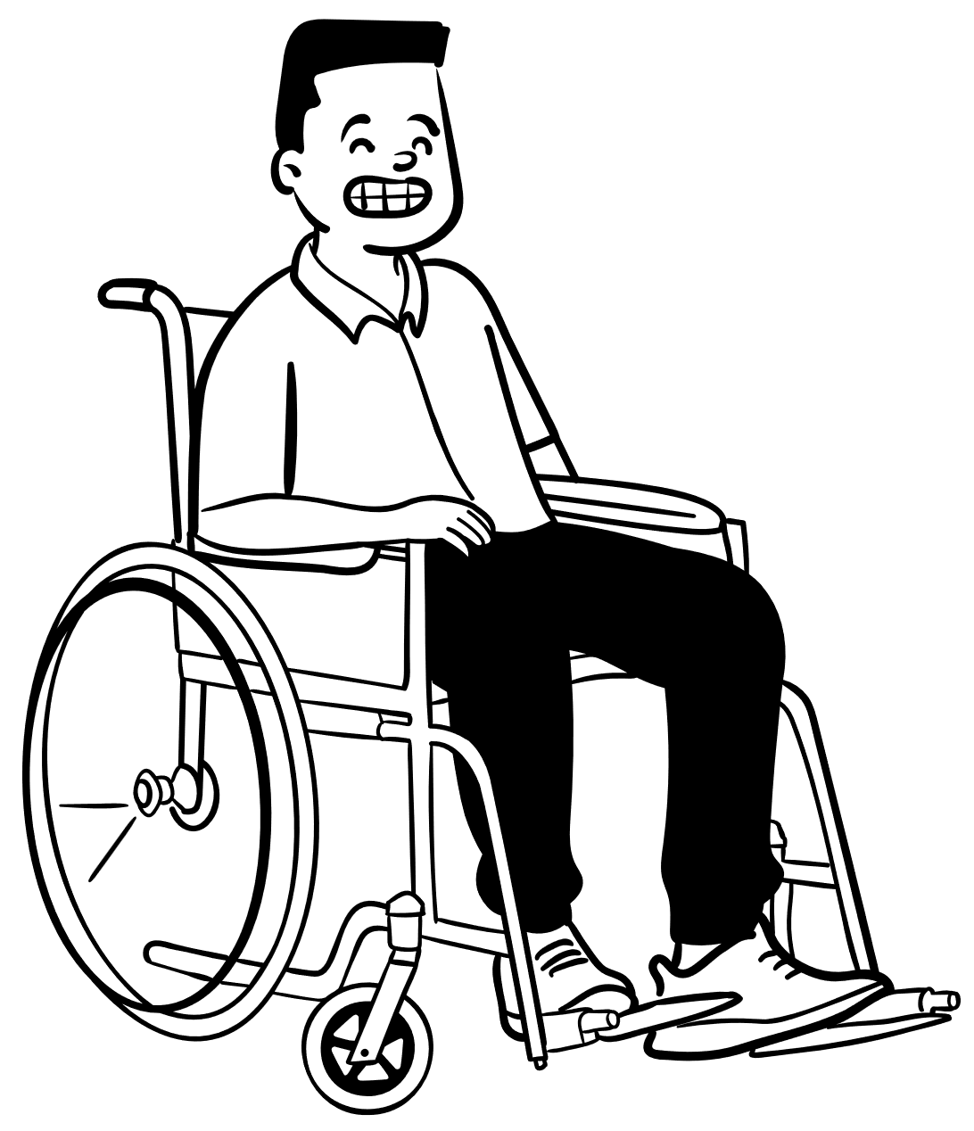**The Right Person.**

The name and photo of the client must be the same on the MAF and the webster pak.

1. **The Right Medication**

The name of the medication must be the same on the MAF and on the webster pak or medication package.

1. **The Right Dose**

The dose of medication must be the same on the MAF and on the webster pak or medication packaging.

1. 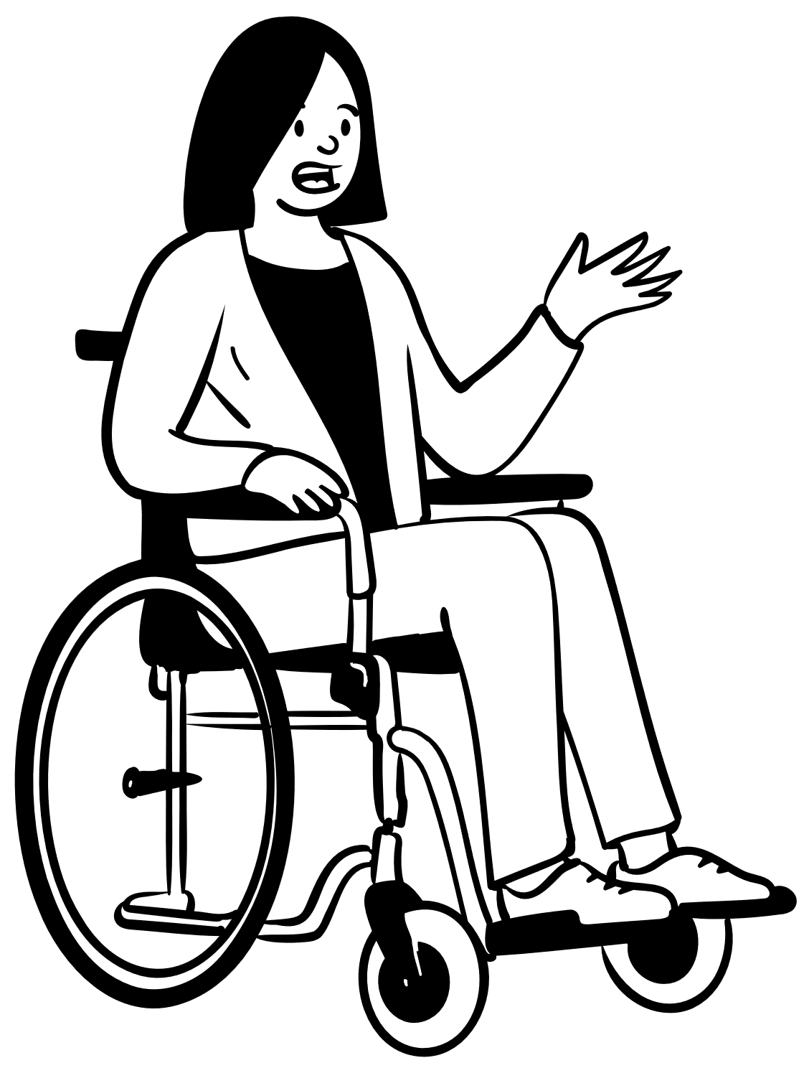**The Right Time.**

Check the MAF to see when the medication should be given. Check the IMRC to see when the medication was last given.

1. **The Right Route.**

Check the MAF to see how the medication should be given.

1. **The Right Documentation.**

Make sure the MAF is current and clear and filled in the right way.

1. **The Right to Refuse.**

The participant has the right to refuse the medication. If they refuse wait and try again.



Check in a respectful way that the participant has swallowed the medication.

If you are unsure, ask the client to show you they have swallowed the medication. Only ask this is you are unsure.

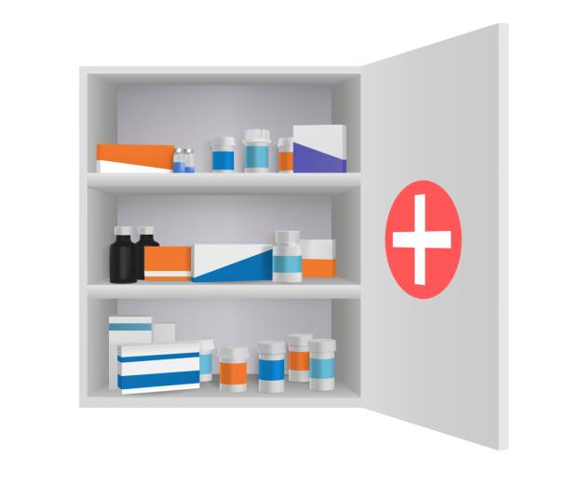  
  
Fill in the **MAF** to show all the medication that has been taken.

Lock away all medications in the right place. If in centre/house there will be a locked cupboard for medication.

If in the community medication needs to be in a locked folder.

Take off your gloves and throw them in the bin. Throw away all other rubbish as well.

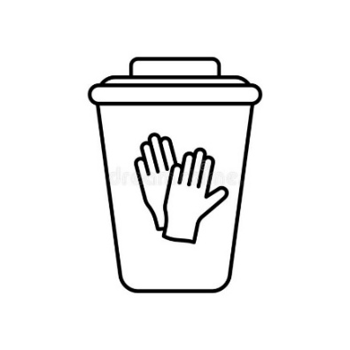

Ensure you wash your hands and any equipment and surfaces you used.

WHAT STAFF MUST **NOT** DO.

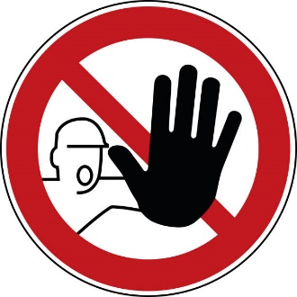Do not give medication to a participant if they have not been trained or assessed as able to give medication.

Do not change a MAF in any way.

Do not leave medication out. You must lock it away in a safe place.

Do not give medication that is out of date or is not the same as on the MAF.

Remain focused on the task and not distracted by anything else when giving medication.

Do not force a participant to take their medication if they don’t want to. Tell your manager or phone your Team Leader for assistance/guidance.

Do not sign the medication chart before the medication has been given.

Do not sign the medication chart if:

* You did not check the medication.
* You did not watch it being given.

Do not leave any part of an entry on the medication chart empty. You must fill in all the spaces.

**Before staff can give medication**

Before staff can give medication to a participant they must:

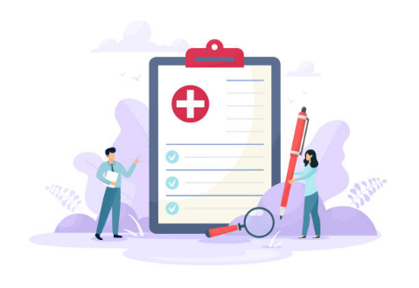

Do all medication training as provided in the AMPEY onboarding session or as required during employment.

Be assessed as competent for administering medication.

Read the AMPEY PTY LTD Medication Policy and Medication Practice Guide.

**Participant who self-administer or manage their own medication.**

Participants will manage and administer their own medication when able too.   
AMPEY will request written advice from a participant’s medical practitioner or guardian, notifying that a participant has appropriate training and skill to assume responsibility for the management of their own medication.   
Participants will be provided with every opportunity to safely manage and administer their own medication.

The self-administration and management of medications by the participant is properly supervised, documented and recorded by AMPEY staff.

**Disposing of medications**

All medications are to be returned to the pharmacist when ceased or disposed of as per the Clinical Waste Management Policy and Procedure.

Medication needs to be sealed in an envelope when being disposed of. Then taken to a pharmacy to be disposed of. No “prescription only” medication may be kept at AMPEY.  
No medication are to be used by or for another participant or kept or allowed to accumulate with other participant medications for “later stock”.

**Short Term Medication**

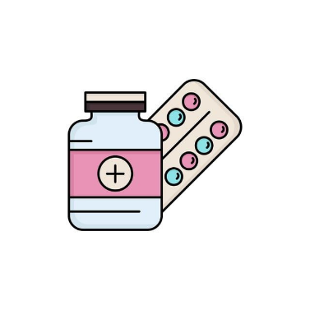Short term medication may be needed for a short period of time. This could be trial medication or antibiotics.   
This medication should be treated the same as routine medication and must be labelled and webster-pak.   
It can only be given for the duration as prescribed by a doctor.

**When things go wrong with medication**

An incident is something that goes wrong. A medication incident is:



A dose of medication have been missed.

A participant does not agree to take their medication.

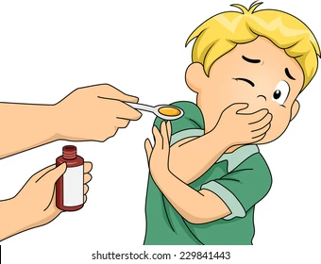

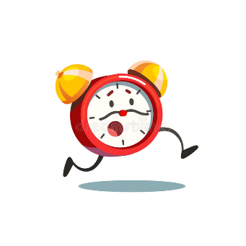

Medication is not taken at the right time.  
**Note -**  it is ok if medication is taken up to 30 minutes before or after the time written on the MAF.



Medication is given to the wrong participant.



The wrong dose of medication is given to a participant.



The medication chart has not been signed the right way to show medication has been given.

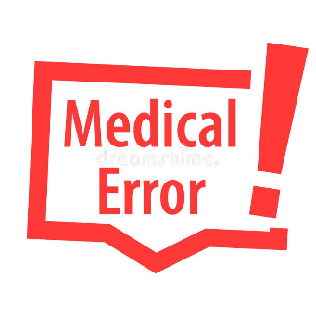

The medication in the webster pak is not the same as what is on the MAF.



Medication is dropped on the floor.



Medication is out of date/expired.



A participant vomits not long after they take their medication.

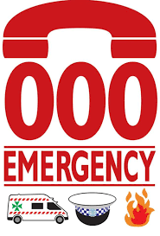

When there is an incident with medication you must:

In an emergency call 000.

Tell your manager/team leader and fill in an Incident Report.

Your manger/team leader might ask you to contact the participant’s GP, pharmacy or other health professionals advice.



AMPEY contact details are: 0411 919 805.



Contact Health Direct if you require more professional advise.

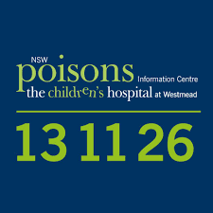Call 1800 022 222

You can call the Poison Information Helpline for guidance:  
  
 Call 13 11 26.

**AMPEY MEDICATION ASSESSMENT**

Before you can administer medication independently you need to pass this competency assessment. You need to pass all theory questions. In addition, you will be assessed on two separate occasions on your practical administration of medication and will need to pass all competencies.

|  |  |
| --- | --- |
| COMPETENCY | The correct practice of administration of medications |
| PRINCIPLE | To ensure that all medications are administered safely to the right participant, at the right time via the right route.  Actions to take in the event of an incident |
| ASSESSMENT | * To assess that the Support Worker has a full understanding of the medication policy and procedure. * To complete the Theory Assessment * To assess the support worker can competently assist the participant with their regular medication. * To monitor and observe the support worker during the administration of medications. * To assess that the support worker has the knowledge and understanding of the processes required if an error occurs or a behavior is exhibited during the medication administration process. |

Staff Name: ______________________________

|  |
| --- |
| How should medication be stored in a home or centre based setting? |
|  |
| How should medication be stored when in the community? |
|  |
| What items can medication be administered from? |
|  |
| What do you need to check when administering medication? |
|  |
| What is the name of equipment used to remove medication from a webster pak? |
|  |
| What are the 7 R’s of medication administration? |
| Right  Right    Right  Right  Right  Right  Right |
| What are the different routes of medication administration? |
|  |
| Name 3 possible medication errors? |
| 1.  2.  3. |
| Describe what process you would take if there was a medication error identified? |
|  |
| What is needed in a participant’s medication folder? |
|  |
| What is the difference between PRN and Regular Medication? |
|  |
| What is the correct procedure for disposing of medication? |
|  |
| What two numbers can you call for medical help regarding medication? |
| Health Direct -  Poison Hotline – |

Competency/Practical Sign Off

|  |
| --- |
| * *AMPEY management or delegate are to conduct this annual reassessment for all staff.* * *All items must be deemed “competent” before the employee may assist participants with medications.* * *Employees are to be reassessed annually, or more frequently if required.* * *Training Guide and Assessment to be easily accessible on the “Onboarding AMPEY Website”.* |

Assessment Sign Off:

Assessors Name: __________________

Assessors Signature: _____________________

Date: _____________________